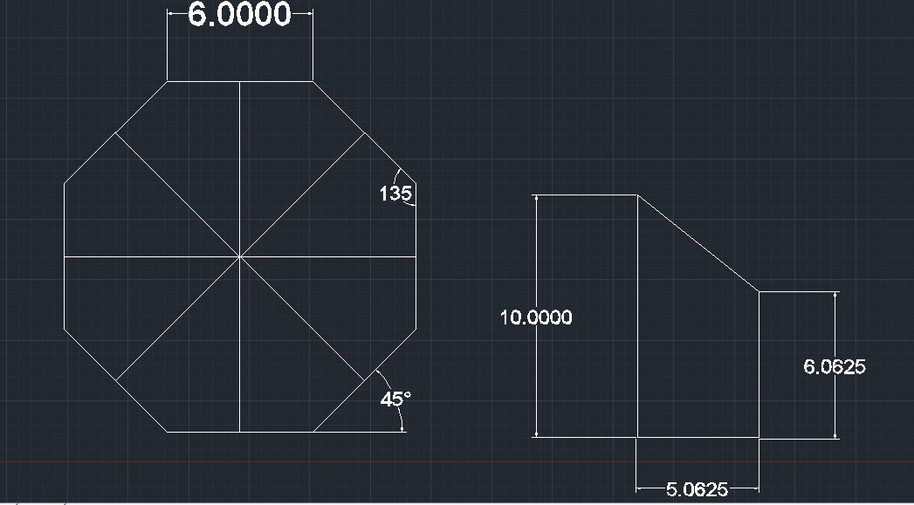

The Depth for this object is 10 inches.

The Depth for this object is 7 inches.

